**CHAPTER 1:** LOAD FREQUENCY CONTROL IN A SINGLE AREA POWER SYSTEM

**TABLE OF CONTENTS**

ACKNOWLEDGEMENT ii

ABSTRACT iv

TABLE OF CONTENTS v

LIST OF FIGURES vi

LIST OF TABLES vii

1. INTRODUCTION 2
   1. REASONS FOR THE NEED OF MAINTAINING CONSTANT FREQUENCY 3
   2. THESIS OBJECTIVE: 3
2. LOAD FREQUENCY CONTROL: 5
   1. LOAD FREQUENCY PROBLEMS: 5
   2. SPEED GOVERNING SYSTEM: 6
      1. MATHEMATICAL MODELLING OF A GENERATOR 6
      2. MATHEMATICAL MODELLING OF LOAD 6
      3. MATHEMATICAL MODELLING FOR PRIME MOVER: 7
      4. MATHEMATICAL MODELLING FOR GOVERNOR 7
   3. AUTOMATIC GENERATION CONTROL: 8
      1. AGC IN A SINGLE AREA: 9
   4. METHODS OF FEEDBACK CONTROL IMPLEMENTATION 9
      1. POLE PLACEMENT TECHNIQUE: 9

2.4.2. OPTIMAL CONTROL SYSTEM 12

1. PROBLEM STATEMENT: 15
   1. WITHOUT THE USE OF AGC 15
   2. USING AGC FOR AN ISOLATED POWER SYSTEM: 17
   3. LOAD FREQUENY CONTROL USING POLE-PLACEMENT DESIGN 18
   4. LOAD FREQUENCY CONTROL USING OPTIMAL CONTROL DESIGN 21

3.5 DISCUSSION 23

1. CONCLUSION 23

REFERENCES 26

**LIST OF FIGURES**

1. Fig 2.1: Mathematical modelling block diagram for a generator 6
2. Fig 2.2: Mathematical modelling Block Diagram of Load 7
3. Fig 2.3: complete block diagram of single area system 8
4. Fig 3.1.Frequency deviation step response without using AGC 16
5. Fig 3.2.Simulation Block Diagram of the system without using AGC 16
6. Fig 3.3 Frequency deviation step using AGC for an isolated system 17
7. Fig 3.4.Simulation block diagram for the given system using AGC for an isolated System 18
8. Fig 3.5: Uncompensated frequency deviation step response 19
9. Fig 3.6 Compensated Frequency deviation step response 20
10. Fig 3.7: Output of the pole placement technique 20
11. Fig 3.8: Output of the LFC using optimal control design 21
12. Fig 3.9 Frequency deviation step response of LFC using optimal control design…21

## LIST OF TABLES

1. Table 4.1 Results Comparison 25

CHAPTER**1**

Introduction

##### INTRODUCTION

Power system is used for the conversion of natural energy to electric energy. For the optimization of electrical equipment, it is necessary to ensure the electric power quality. It is known three phase AC is used for transportation of electricity. During the transportation ,both the active and reactive power balance must be maintained between the generation and utilization AC power. When either frequency or voltage changes equilibrium point will shift. Good quality of electrical power system means both the voltage and frequency to be fixed at desired values irrespective of change in loads that occurs randomly. It is in fact impossible to maintain both active and reactive power without control which would result in variation of voltage and frequency levels. To cancel the effect of load variation and to keep frequency and voltage level constant a control system is required. Though the active and reactive powers have a combined effect on the frequency and voltage, the control problem of the frequency and voltage can be separated. Frequency is mostly dependent on the active power and voltage is mostly dependent on the reactive power. Thus the issue of controlling power systems can be separated into two independent problems. The active power and frequency control is called as load frequency control (LFC). The most important task of LFC is to maintain the frequency constant against the varying active power loads, which is also referred as un- known external disturbance.

Power exchange error is an important task of LFC .Generally a power system is composed of several generating units. To improve the fault tolerance of the whole power system, these generating units are connected through tie-lines. This use of tie-line power creates a new error in the control problem, which is the tie-line power exchange error. When sudden change in active power load occurs to an area, the area will get its energy through tie-lines from other areas. Eventually the area that is subject to the change in load should balance it without external support. Or else there will be economic conflicts between the areas. This is why each area requires separate load frequency controller to regulate the tie line power exchange error so that all the areas in an interconnected system can set their set points differently. In short, the LFC has two major duties, which are to maintain the desired value of frequency and also to keep the tie line power exchange under schedule in the presence of any load changes. Also, the LFC has to be unaffected by unknown external disturbances and system model and parameter variation.

##### REASONS FOR THE NEED OF MAINTAINING CONSTANT FREQUENCY:

* + 1. The speed of a.c. motors are directly related to the frequency.
    2. If the normal operating frequency is 50 Hz and the turbines run at speeds corresponding to frequencies less than 47.5 Hz or above 52.5 Hz, then the blades of the turbines may get damaged.
    3. The operation of a transformer below the rated frequency is not desirable. When frequency goes below rated frequency at constant system voltage then the flux in the core increases and then the transformer core goes into the saturation region.
    4. With reduced frequency the blast by ID fans and FD fans decrease, and so the generation decreases and thus it becomes a multiplying effect and may result in shut down of the plant.

##### THESIS OBJECTIVE:

The objective of the thesis is to consider an isolated power station and find the steady state frequency deviation step response and also time domain specifications using various control techniques in MATLAB and Simulink environment and to study which one yields better results.

CHAPTER**2**

LOAD FREQUENCY

CONTROL

##### LOAD FREQUENCY CONTROL:

##### LOAD FREQUENCY PROBLEMS:

If the system is connected to numerous loads in a power system, then the system frequency and speed change with the characteristics of the governor as the load changes. If it’s not required to maintain the frequency constant in a system then the operator is not required to change the setting of the generator. But if constant frequency is required the operator can adjust the velocity of the turbine by changing the characteristics of the governor when required. If a change in load is taken care by two generating stations running parallel then the complex nature of the system increases. The ways of sharing the load by two machines are as follow:

1. Suppose there are two generating stations that are connected to each other by tie line. If the change in load is either at A or at B and the generation of A is regulated so as to have constant frequency then this kind of regulation is called as **Flat Frequency Regulation.**
2. The other way of sharing the load is that both A and B would regulate their generations to maintain the frequency constant. This is called **parallel frequency regulation.**
3. The third possibility is that the change in the frequency of a particular area is taken care of by the generator of that area thereby maintain the tie-line loading. This method is known as **flat tie- line loading control**.
4. In **Selective Frequency control** each system in a group is taken care of the load changes on its own system and does not help the other systems, the group for changes outside its own limits.
5. In **Tie-line Load-bias control** all the power systems in the interconnection aid in regulating frequency regardless of where the frequency change originates.

##### SPEED GOVERNING SYSTEM:

##### MATHEMATICAL MODELLING OF A GENERATOR:

With the use of swing equation of a synchronous machine to small perturbation, we have

=𝝙Pm – 𝝙Pe (2.1)

Or in terms of small change in speed

=

(  ) (2.2)

Laplace Transformation gives,

𝝙Ω(s) =

[𝝙Pm(s) – 𝝙Pe(s)] (2.3)

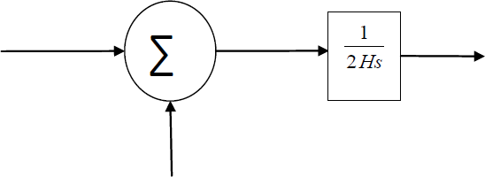

Fig 2.1: Mathematical modelling block diagram for a generator

##### MATHEMATICAL MODELLING OF LOAD:

The load on a power system consists of variety of electrical drives. The load speed characteristic of the load is given by:

ΔPe = ΔPL + D Δω (2.4)

where ΔPL is the non-frequency sensitive change in load, DΔω is the load change that is frequency sensitive.

D is expressed as % change in load divided by % change in frequency **.**

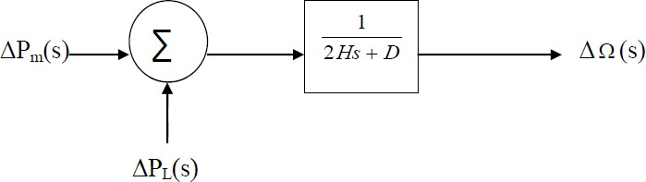

Fig 2.2: Mathematical modelling Block Diagram of Load

##### MATHEMATICAL MODELLING FOR PRIME MOVER:

The source of power generation is the prime mover. It can be hydraulic turbines near waterfalls, steam turbine whose energy come from burning of coal, gas and other fuels. The model of turbine relates the changes in mechanical power output ΔPm and the changes in the

steam valve position ΔPV.

GT = ( ) =

(2.5)

( )

where the turbine constant is in the range of 0.2 -2.0s.

##### MATHEMATICAL MODELLING FOR GOVERNOR :

When the electrical load is increased suddenly then the electrical power exceeds the input mechanical power. This deficiency of power in the load side is compensated from the kinetic energy of the turbine. Due to this reason the energy that is stored in the machine is decreased and the governor sends signal for supplying more volumes of water, steam or gas to increase the speed of the prime mover to compensate deficiency in speed.

𝝙P =𝝙P - (2.6)

g ref

In s-domain

𝝙Pg=𝝙Pref - Δf (2.7)

The command ΔPg is transformed through amplifier to the steam valve position command ΔPV. We assume here a linear relationship and considering simple time constant we get this s-domain relation

𝝙PV = Pg(s) (2.8)

Combining all the above block diagrams, for a isolated area system we get the following:

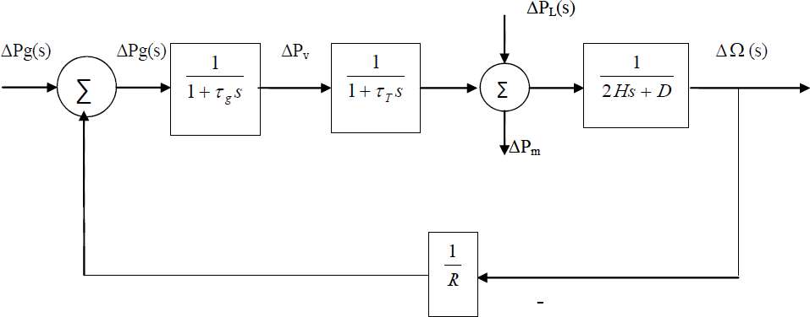

Fig 2.3: complete block diagram of single area system

The closed loop transfer function that relates the load changeto the frequency deviation

is

( ) ( )( )

(2.9)

( )( )( )

##### AUTOMATIC GENERATION CONTROL:

If the load on the system is suddenly increased, then the speed of the turbine drops before the governor could adjust the input of the steam to this new load. As the change in the value of speed decreases the error signal becomes lesser and the position of the governor and not of the fly balls gets nearer to the point required to keep the speed constant. One way to regain the speed or frequency to its actual value is to add an integrator on its way. The integrator will monitor the average error over a certain period of time and will overcome the offset.

Thus as the load in the system changes continuously the generation is adjusted automatically to restore the frequency to its nominal value. This method is known as automatic generation control. In an interconnected system consisting of several areas, the task of the AGC is to divide the load among the system, stations and generators so to achieve maximum economy and uniform frequency.

##### AGC IN A SINGLE AREA:

With the main LFC loop, change in the system load will result in a steady state frequency deviation ,depending on the speed regulation of the governor. To reduce the frequency deviation to zero we need to provide a reset action by using an integral controller to act on the load reference setting to alter the speed set point. This integral controller would increase the system type by 1 which forces the final frequency deviation to zero. The integral controller gain need to be adjusted for obtaining satisfactory transient response.

The closed loop transfer function of the control system is given by:

( ) ( )( )

(2.10)

( )( )( )

##### METHODS OF FEEDBACK CONTROL IMPLEMENTATION:

##### POLE PLACEMENT TECHNIQUE:

This is one of the design methods. Here we assume that all the state variables can be measured and are available for feedback. The poles of the closed ζ appropriate state feedback gain matrix if the system is completely state controllable.

At first we need to determine the desired closed loop poles based on transient response, frequency response.

Let the desired closed loop poles are to be at s=µ1,s=µ2,… s=µn.

In conventional approach to the design of a single input, single output control system, we design a compensator such that dominant poles have a desired damping ratio ζ and a desired undamped natural frequency ωn. In this approach, effects on the responses of non-dominant closed loop are to be negligible. But this pole placement approach specifies all closed loop

|  |  |
| --- | --- |
| poles.  Consider a control system: |  |
| Ẋ=AX+BU | (2.11) |
| Y=CX+DU | (2.12) |
| X: state vector |  |
| Y: output signal |  |
| U: control signal |  |
| A: n*n |  |
| B: n*1 |  |
| C: 1*n |  |
| D: constant(scalar) |  |
| Let the control signal, U be |  |
| U=-KX | (2.13) |

This means the control signal U is determined by an instantaneous state. Such a scheme is called state feedback. The K matrix is called State feedback gain matrix.

Now, Ẋ= (A-BK)X (2.14)

The eigen values of matrix A-BK are called regulatory poles. The problem of placing the regulatory poles at the desired location is called Pole placement problem.

##### DETERMINATION OF K-MATRIX USING TRANSFORMATION MATRIX T:

Ẋ=AX+BU, U=-KX

STEP1: First check whether the system is completely state controllable. STEP2: From the characteristic polynomial for matrix A,

|SI-A|=sn+a1sn-1+ +an.

Determine the values of a1,a2,… an.

STEP3: Determine the transformation matrix T that transforms the system state equation into controllable canonical form.

STEP4: Using the desired eigen values write the desired characteristic polynomial (s- µ1)(s- µ2)……..(s-µn)= sn + α1sn-1 + + αn

Determine the values of α1, , αn.

STEP5: The required state feedback gain matrix K can be determined, thus

K=[ (αn- an) (αn-1- an-1)……….( α1- a1)]T-1 (2.15)

##### DETERMINATION OF K-MATRIX USING DIRECT SUBSTITUTION METHOD:

If the system is of low order (n<=3),direct substitution of matrix K into desired characteristic polynomial may be simpler.

Let for n=3,

K= [k1 k2 k3]

Substitute this K matrix into desired characteristic polynomial |SI-A+BK| and equate it to (s- µ1)( s- µ2)( s- µ3) or

|SI-A+BK|=(s- µ1)( s- µ2)( s- µ3)

So, by equating the coefficients of like powers of s on both sides,it is possible to determine the values of k1,k2,k3.

##### 2.4.1.3. ACKERMAN’S FORMULA:

K= (0 0 ………1)[B AB A2B ……… A(n-1)B](-1)[α1A(n-1) + α2A(n-2) +………+ α(n)] (2.16)

##### 2.4.2. OPTIMAL CONTROL SYSTEM:

This is a technique that is applied in the control system design which is implemented by minimizing the performance index of the system variables. Here we have discussed the design of the optimal controllers for the linear systems with quadratic performance index, which is also known as the linear quadratic regulator. The aim of the optimal regulator design is to obtain a control law **u*(x, t)** which can move the system from its initial state to the final state by minimizing the performance index. The performance index which is widely used is the quadratic performance index.

Consider a plant:

X (t) =Ax (t) + Bu (t)

The aim is to find the vector **K** of the control law U (t) = -K (t)*x (t)

which minimises the value of the quadratic performance index **J** of the form:

∫ ( )

Where Q is a positive semi definite matrix and **R** is real symmetric matrix.

(2.17)

To obtain the solution we make use of the method of Langrange multipliers using an n vector of the unconstrained equation

[x, λ, u, t]= [x’Qx + u’Ru] + λ’ [Ax + Bu – x’] (2.18) The optimal values determined are found by equating the partial derivative to zero.

We know the Riccati equation as:

p(t)= -p(t)A - A’p(t) - Q+ p(t)BR-1B’p(t) (2.19)

We have assumed p(t) as a time varying positive matrix satisfying

λ = 2p(t)x* (2.20)

By solving the equation (19) the solution of the state equation in association with optimal control can be obtained.

Compensators are mostly used to satisfy all desired specifications in a system. In most of the cases the system needs to fulfil some more specifications which is difficult to attain in case of a compensated system. As an alternative we use Optimal Control system. The trial and error system for the compensated design system makes it difficult for the designers to attain those specifications. This trial and error process works well for system with a single input and a single output. But for a multi-input-multi-output system the trial and error method is replaced with Optimal Control design method where the trial and error uncertainties are excluded in parameter optimization method. It consists of a single performance index specially the integral square performance index.

CHAPTER**3**

**SIMULATIONS AND**

**RESULTS**

##### PROBLEM STATEMENT:

An isolated power station has the following parameters Turbine time constant = 0.5 s

Governor time constant = 0.2 s Governor inertia constant = 5 s Governor speed regulation = R per unit

The load varies by 0.8 per cent for a 1 per cent change in frequency ( D=0.8)

The governor speed regulation is set to R = 0.05 per unit. The turbine rated output is 250 MW at nominal frequency 50 Hz. A sudden load change of 50 MW (𝝙pL= 0.2 Per unit) occurs.

Find steady state Frequency deviation in Hz. Also obtain time domain performance specifications and the frequency deviation step response.

##### WITHOUT THE USE OF AGC:

To obtain the time domain specifications and the step response following command is used: Pl= 0.2; num= [0.1 0.7 1];

den= [1 7.08 10.56 20.8];

t= 0:.02:10;

c= -pl* step(num,den,t);

plot(t, c), xlabel(‘t, sec’), ylabel(‘pu’) title(‘Frequency deviation step response’),grid timespec(num, den)

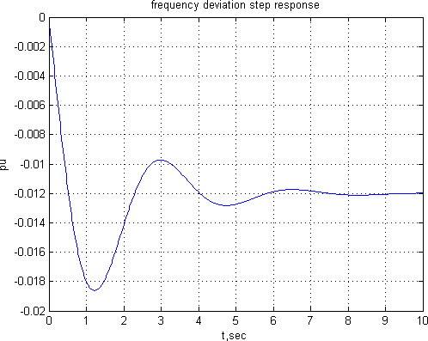

Fig 3.1.Frequency deviation step response without using AGC

The time domain specifications are:

Peak time= 1.223 Percentage overshoot= 54.80

Rise time= 0.418

Settling time= 6.8

The Simulink model for the above system is:

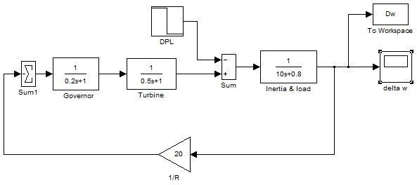

Fig 3.2.Simulation Block Diagram of the system without using AGC

##### USING AGC FOR AN ISOLATED POWER SYSTEM:

Substituting the system parameters we get the closed loop transfer function as: T(s)= (0.1s3+ 0.7s2+ s)/ (s4+ 7.08s3+ 10.56s2+ 20.8s+ 7)

To find the step response following command is used:

pl= 0.2;

ki= 7;

num= [0.1 0.7 1 0];

den= [1 7.08 10.56 20.8 7];

t= 0:.02:12;

c= -pl* step(num, den, t); plot(t, c),grid

xlabel(‘t, sec’), ylabel(‘pu’) title(‘Frequency deviation step response’)

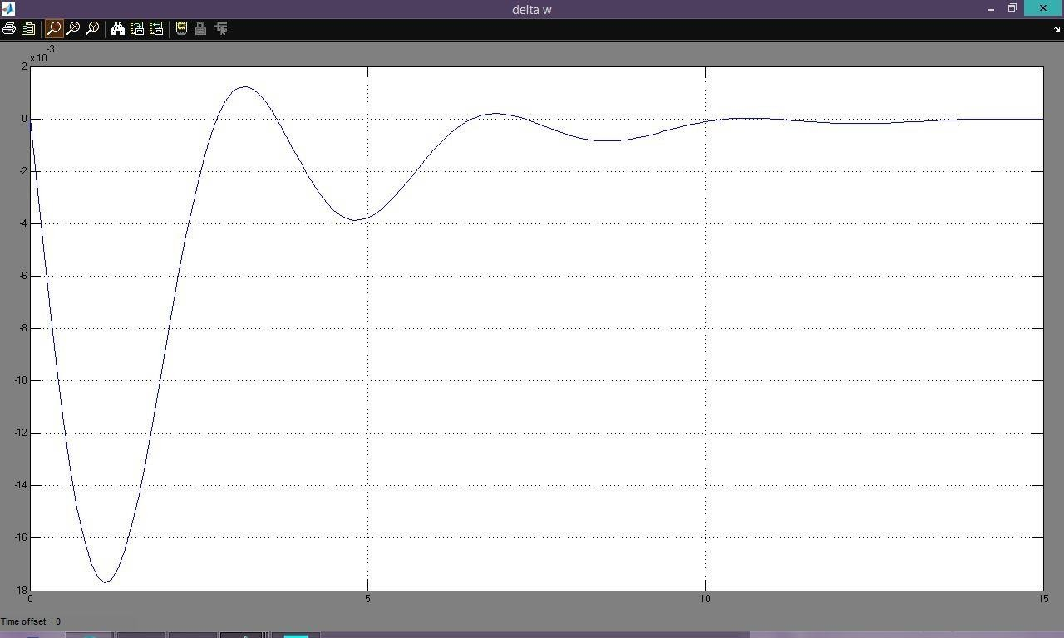

Fig 3.3 Frequency deviation step using AGC for an isolated system

From the step response we have seen that the steady state frequency deviation is zero, and the frequency returns to its actual value in approximately 10seconds.

The Simulink model for the above system is:

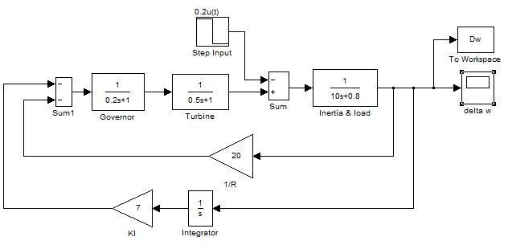

Fig 3.4.Simulation block diagram for the given system using AGC for an isolated system

##### LOAD FREQUENY CONTROL USING POLE-PLACEMENT DESIGN:

PL = 0.2;

A = [-5 0 -100; 2 -2 0; 0 0.1 -0.08];

B = [0; 0; -0.1]; BPL = B*PL;

C = [0 0 1]; D = 0;

t=0:0.02:10;

[y, x] = step(A, BPL, C, D, 1, t);

figure(1), plot(t, y), grid xlabel('t, sec'), ylabel('pu') r =eig(A)

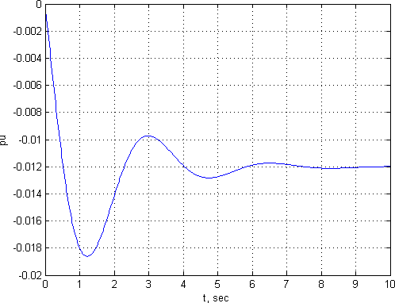

Fig 3.5: Uncompensated frequency deviation step response Settling time of the uncompensated system is 4seconds.

Now we are interested to find k such that the roots of the characteristic equation is at -2+j6,- 2-j6 and -3.

Following commands is required to find the desired output: P=[-2.0+j*6 -2.0-j*6 -3];

[K, Af] = **placepol**(A, B, C, P); t=0:0.02:4;

[y, x] = step(Af, BPL, C, D, 1, t);

figure(2), plot(t, y), grid xlabel('t, sec'), ylabel('pu')

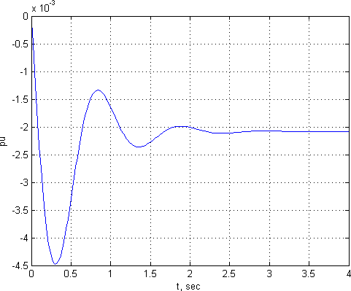

Fig 3.6 Compensated Frequency deviation step response The result of the above mentioned MATLAB code is:

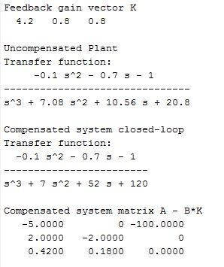

Fig 3.7: Output of the pole placement technique

Thus, the state feedback constants k1= 4.2, k2= 0.8 and k3= 0.8 results in the desired characteristic equation roots. We have seen transient response has improved and the response settles to a steady state value of -.0017 p.u.in 2.5 seconds.

##### LOAD FREQUENCY CONTROL USING OPTIMAL CONTROL DESIGN:

Performance index is given as:

J=∫ (    )

MATLAB CODE:

PL=0.2;

A = [-5 0 -100; 2 -2 0; 0 0.1 -0.08];

B = [0; 0; -0.1]; BPL=PL*B;

C = [0 0 1];

D = 0;

Q = [20 0 0; 0 10 0; 0 0 5];

R = .15;

[K, P] = lqr2(A, B, Q, R) Af = A - B*K t=0:0.02:1;

[y, x] = step(Af, BPL, C, D, 1, t);

plot(t, y), grid

xlabel('t, sec'), ylabel('pu')

The output is:

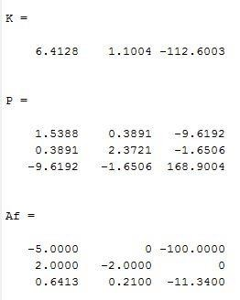

Fig 3.8: Output of the LFC using optimal control design

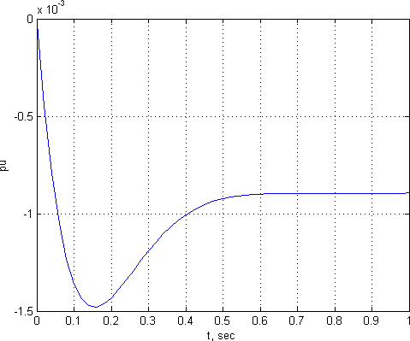

Fig 3.9 Frequency deviation step response of LFC using optimal control design

We see that the transient response settles to a steady state of -0.0007 pu in about 0.6seconds.

##### 3.5 DISCUSSION:

From the above simulations it is clear that the Figure 3.6 which depicts the deviation in frequency of the isolated system has more ripples and its counterpart in Figure 3.9

And has fewer ripples. It is clear from the graphical representation of the step response that the settling time is more in an uncompensated system than that for a compensated system while using pole placement technique. When we have a look into the step response in the Optimal Controller design then it is observed that the settling time is comparatively less. The system reaches equilibrium faster than that for the controllers using pole placement design. In general there are two situations where the compensation is required. The first case is when the system is unstable. The second case is when the system is stable but the settling time is more. Hence using pole placement technique is nothing but using the compensation scheme to reduce the settling time of the system. It is clearly shown that the system reached faster to a steady state in compensated system than for an uncompensated system.

|  |  |  |
| --- | --- | --- |
|  | Steady State Frequency  Deviation | Settling Time |
| Uncompensated System | -0.0096 pu | 6.8s |
| Automatic Generation  Control | 0 pu | 10s |
| Pole Placement Design | -0.0017 pu | 2.5s |
| Optimal Control Design | -0.0007 pu | 0.6s |

Table 4.1 Results Comparison

CHAPTER**4**

CONCLUSION

1. **CONCLUSION:**

This project shows a case study of designing a controller that can withstand optimal results in a single area power system when the input parameters of the system are changed. Four methods of Load Frequency Control were studied taking an isolated power system into account. It was seen that the Automatic Generation Control was better than the conventional uncompensated system in terms of steady state frequency deviation. Then the Pole Placement Control was seen to have better results than the AGC in terms of settling time. Finally the Optimal controller design provided the best results in terms of both frequency deviation and settling time and achieved required reliability when the input parameters were changed.

**REFERENCES:**

1. Muthana T. Alrifai and Mohamed Zribi “Decentralized Controllers for Power System Load Frequency Control” *ASCE Journal*, Volume 5, Issue II, June, 2005.
2. Wadhwa C. L., *Electrical Power system*s, 2010 Edition, New Age International Publisher, New Delhi.
3. Hadi Saadat, *Power system analysis.* Tata McGraw Hill 2002 Edition, New Delhi
4. I.J. Nagrath and M.Gopal, *Control System Engineering*. 2002 Edition, New Age International Publisher, New Delhi.
5. Sivaramakrishnan, A. Y., Hariharan, M. V. and Srisailam, M. C. "Design of Variable Structure Load Frequency Controller Using Pole Assignment technique", *Int. Journal of Control*, Vol. 40, No. 3, pp. 487-498,1984.